Python Mega Projects

Mega Project 1 - Simple Calculator
Python code:

# Simple Calculator by Ilyan khan serial number: 20
while True:
num1=input("Enter first number: ")
if num1=='q':
break
num2=int(input("Enter second number: "))
choice=input("Enter operation: (+,-,*,/) ")
if choice=='+':
print("The addition of ",num1,"and",num2," is ",int(num1)+num2,"\n")
elif choice=='-':
print("The subtraction of ",num1,"and",num2," is ",int(num1)-num2,"\n")
elif choice=='*':
print("The multiplication of ",num1,"and",num2," is ",int(num1)*num2,"\n")
elif choice=='/':
print("The division of ",num1," and ",num2," is ",int(num1)/num2)

Output:

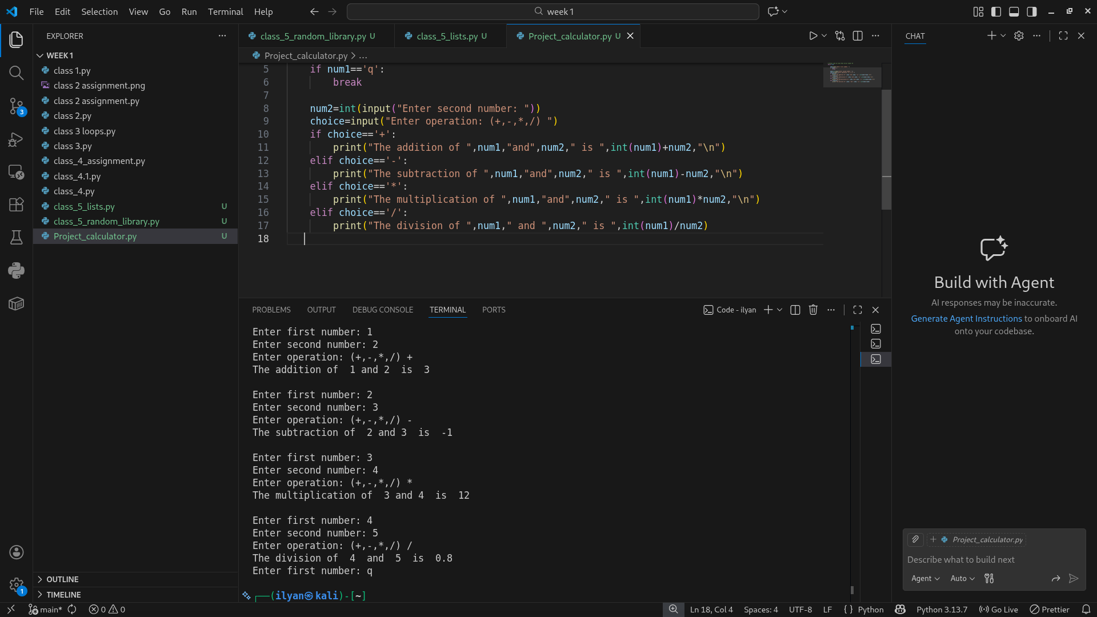

Mega Project 2 - Random Number Guessing Game
Python code:

# A simple random number guessing game by Ilyan khan Serial number: 20
import random
secret_number= random.randint(1,100)
print("I have selected a random number betwen 1 to 100. Can you guess it?")
attempts=0
while True:
guess = int(input("Enter your Guess: "))
attempts +=1
if guess < secret_number:
print("The number is higher than your guess. Try again.\n")
elif(guess>secret_number):
print("The number is lower than your guess. Try again.\n")
else:
print("Congratulations! You've guessed the correct number in",attempts,"attempts.")
break

Output:

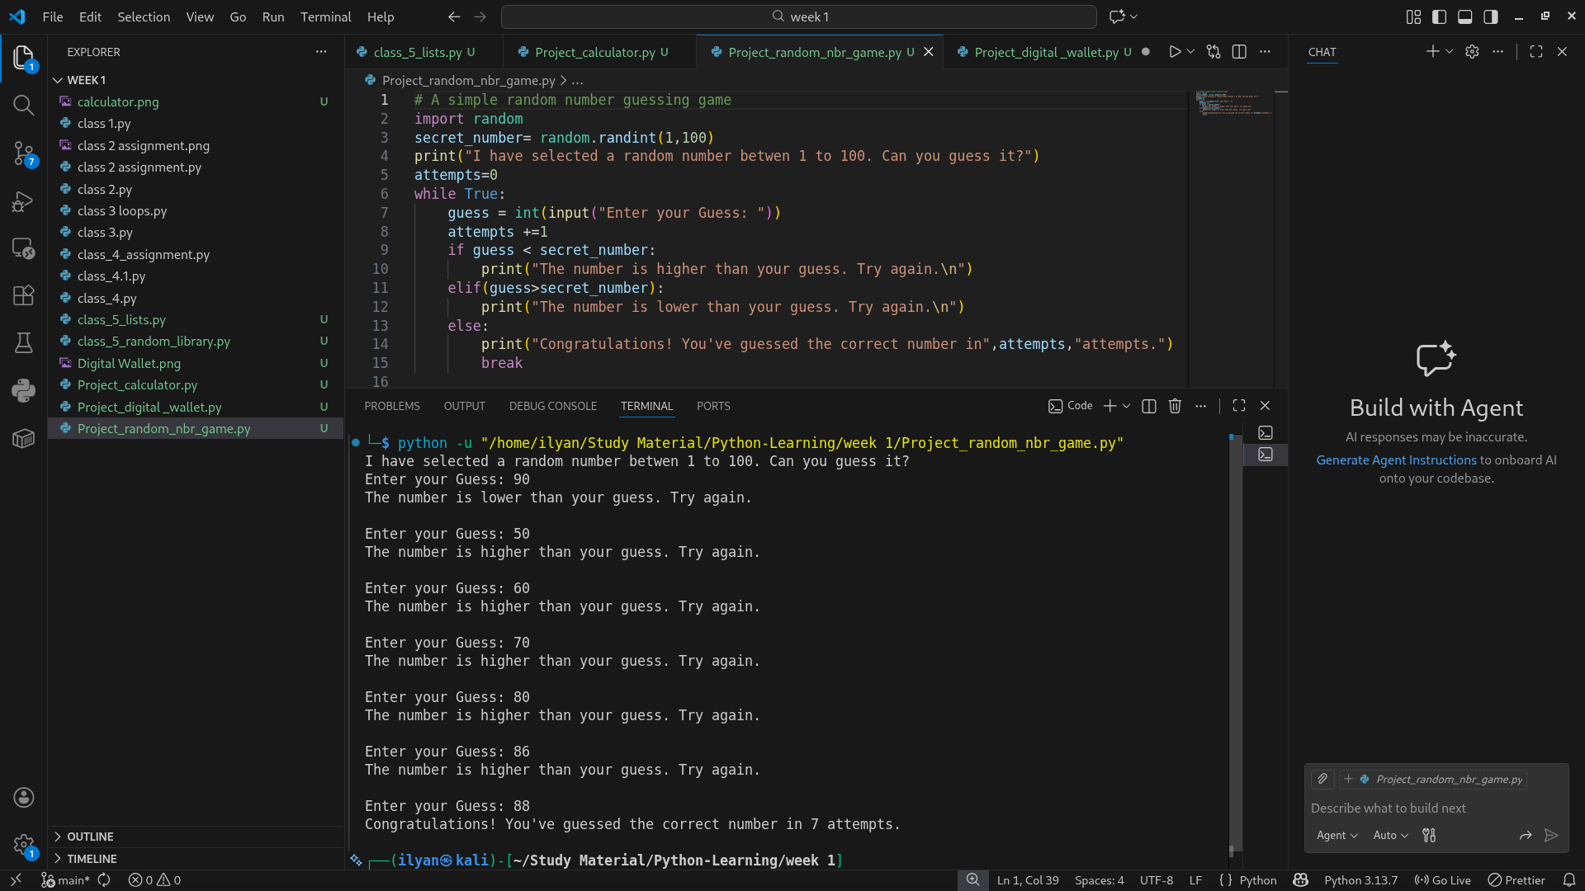

Mega Project 3 - Digital wallet
Python code:
# Digital Wallet Project by Ilyan khan Serial Number:20
amount_list=[]
reason_list=[]
while True:
print("Digital wallet options: ")
print("1. Add amount and reason.\n2. View Total amount and reasons.\n3. Exit.")
choice=int(input("Enter your choice: "))
if choice==1:
amount=int(input("Enter the amount to add: "))
reason=input("Enter the reason for this amount: ")
amount_list.append(amount)
reason_list.append(reason)
print("Amount added successfully.\n")
elif(choice==2):
total=sum(amount_list)
print("Total amount in wallet: ",total)
print("Reasons for amounts added: ",reason_list)
elif(choice==3):
print("Exiting the digital wallet.")
break

else:
print("Invalid choice. Please try again.\n")

Output:
